BAPTIST CHURCH

***OCTOBER***

pe02110_October Nursery Schedule

7 0-2 Year Olds Shirley Marecle

3-4 Year Olds Yoli Oliver

14 0-2 Year Olds Lisa Chrisner

3-4 Year Olds Becky Yount

21 0-2 Year Olds Ashley Smothmermon

3-4 Year Olds Elizabeth McMcanus

Helper Garlyn Radford

28 0-2 Year Olds Rachel Edwards

3-4 Years Paula Knobloch/Judy Broussard

**Weekly Service & Activity Schedule:**

SUNDAY

Sunday School 9:45 a.m.

Morning Worship Services 11:00 a.m.

Youth Activities 5:30 p.m.

Evening Services 6:00 p.m.

MONDAY

“Work-It-On-Out” 6:00 p.m.

WEDNESDAY

“Work-It-On-Out” 6:00 p.m.

Youth Worship 6:30 p.m.

Wednesday Services 7:00 p.m.

THURSDAY

“Work-It-On-Out” 6:00 p.m.

Ladies Bible Study 7:00 p.m.

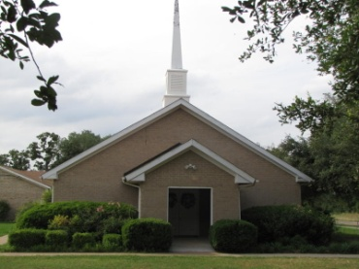

1662 CR 305

McDade, TX 78650

Phone: (512) 273-2743

Email: [KnobbsSpringsBaptist@gmail.com](mailto:KnobbsSpringsBaptist@gmail.com)



*KnobbsSpringsBC.com*

Interim Pastor

Brother Dwight Reagan

Home: 512-247-6448 / Cell: 512-964-1433

Email: dwlReagan@aol.com

**Other Contacts**

*Cleyon Davis – Treasurer*

(512) 856-2524

*Kimberly Tabor – Office Manager*

(512) 698-2804

**October Ushers**

TBA

**October Hostesses**

Dianne Stutes, Mickey Stanford

Judie Coffey, Theresa Bartlett

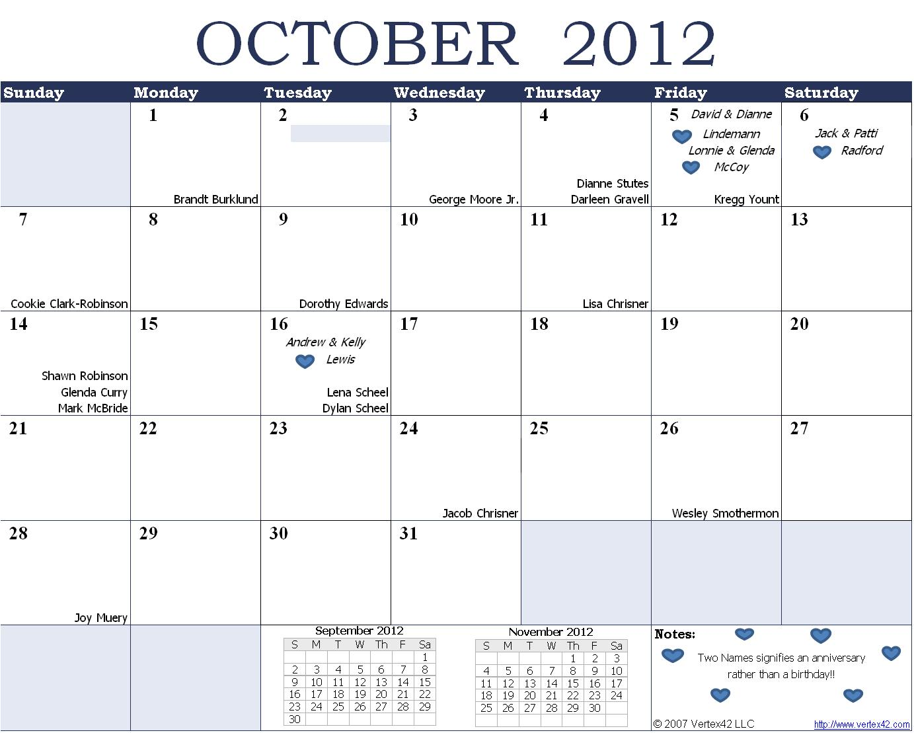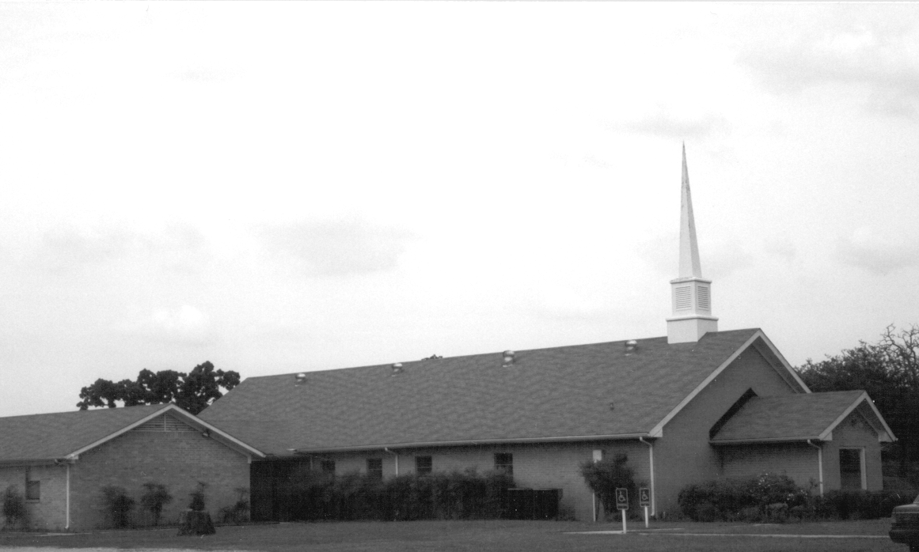

Please email KnobbsSpringsBaptist@gmail.com to be removed from our mailing list. Thanks!

October Newsletter

Knobbs Springs Baptist Church

1662 CR 305

McDade, TX 78650

Non-Profit Organization

U. S. Postage Paid

Permit # 1

McDade, Texas